[space, 12p, bold, centered, single space, 0 indent]
[space, 12p, centered, single space, 0 indent]
[PAPER TITLE, 12p, bold, capital, centered, single space, 0 indent]
[space, 12p, centered, single space, 0 indent]
[author name , author surname, nr (for the same affiliation will be used the same number; if all authors belong to the same affiliation will not use numbers),
12p, centered, single space, 0 indent]
[space, 12p, centered, single space, 0 indent]
^{nr} [institution, department, address, e-mail (only for presentation person), 10p, italic, centered, single space, 0 indent]
[space, 10p, centered, single space, 0 indent]
[space, 10p, centered, single space, 0 indent]
Keywords [11p, bold]: [3-5 keywords separated by comma; 11p, justified, single space, 0 indent]
[space, 12p, left, single space, 0 indent]
Abstract [11p, bold]: [Summary containing: topic justification, objectives, materials, the method, results, discussions, conclusions. The summary may include figures, photos, graphs or diagrams. Summary will be limited to one page. Page will be filled at least 75%. 11p, justified, single space, 0 indent]
[space, 12p, left, single space, 0 indent]
Selective references [10 p, bold]:
[First name initial. Author last name, Title of paper in Italics. Name of Journal, Vol., No., (month and year of the edition), p. xx-yy; 10p, justified, single space, 0 indent].
[space, 12p, left, single space, 0 indent]
[space, 12p, left, single space, 0 indent]
Acknowledgements [11p, bold]: [thanks, if there are, 11p, justified, single space, 0 indent]

Paper A4, margins 25mm all around, general font Calibri

See page 2 for example!

OVERVIEW ON PRODUCTION OF METALLIC FOAMS

Radu Stratulat¹, Sorina Dragomir², Costel Costescu¹

¹ Transilvania University of Brasov, Material Science Department, 29 Eroilor Blvd., 500036, Brasov, Romania
² Transilvania University of Brasov, Materials Engineering and Welding Department, 29 Eroilor Blvd.,
500036, Brasov, Romania, e-mail: s_drag@yahoo.com

Keywords: metallic foam, foaming process, precursor material

Abstract: The first method of foaming aluminum and aluminum alloys is being exploited by Norsk Hydro ASA in Norway and by Cymat Technologies in Canada [1,2]. According to this process silicon-carbide, aluminum-oxide, or magnesium-oxide particles are used to enhance the viscosity of the melt. Therefore, the first step comprises the preparation of an aluminum melt containing one of these substances (MMC). This step reportedly requires sophisticated mixing techniques to ensure a uniform distribution of particles. A variety of aluminum alloys can be used. The melt is foamed in second step by injecting gases (air, nitrogen, argon) into it using specially designed rotating impellers or vibrating nozzles. These generate very fine gas bubbles in the melt and distribute them uniformly. The resultant viscous mixture of bubbles and metal melt floats up to the surface of the liquid where it turns into fairly dry liquid foam, as the liquid metal drains out. Because ceramic particles are in the melt, the foam presented in Fig. 1 is relatively stable. It can be pulled off the liquid surface (e. g. with a conveyor belt) and is then allowed to cool down and solidify [3].
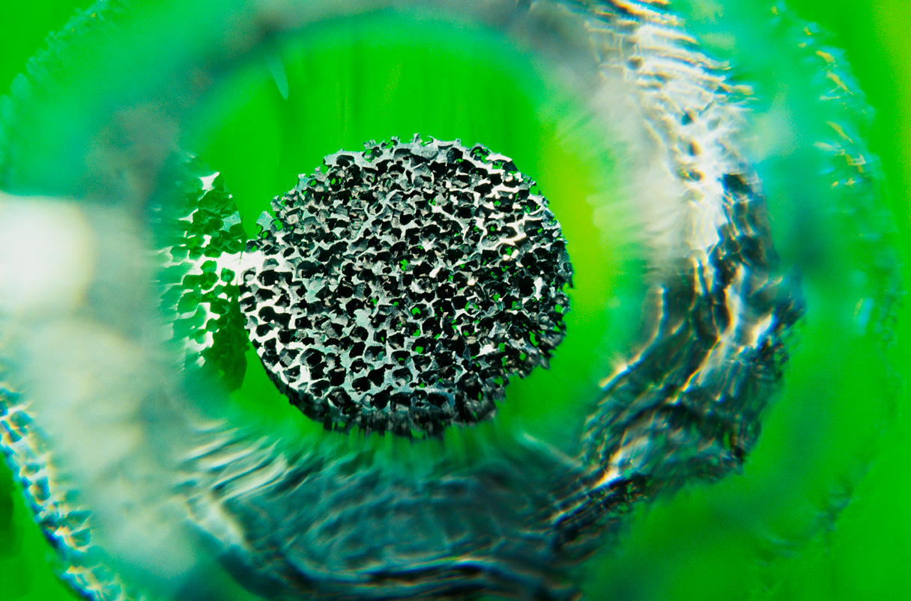

Fig. 1. Aluminum foam [2]

Selective references:
1. P. Asholt, Metal Foams and Porous Metal Structures, ed. J. Banhart, M. F. Ashby and N. A. Fleck, Bremen, Germany, MIT-Verlag, 1999, p. 133.
2. http://www.constellium.com/aluminium-innovation/innovation-cells.
3. J. Banhart, Manufacturing Routes for Metallic Foams, JOM, 52, Dec. 2000, p. 22 – 27.

Acknowledgements: We hereby acknowledge the structural founds project PRO-DD (POS-CCE, O.2.2.1., ID 123, SMIS 2637, ctr. No 11/2009) for providing the infrastructure used in this work.

